COPPA Integration Architectural Design
Vinay Gangoli
SemanticBits, LLC

Document Version
Version | Date | Author | Changes
1.0 | 08/19/2009 | Vinay Gangoli | Initial Draft

Introduction

Background
The COPPA framework is the source of record for all persons (investigators and research staffs), organization, and protocol data. A COPPA enabled C3PR/CAAERS instance is expected (at all times) to display the latest information for COPPA managed entities. A C3PR/CAAERS deployed instance will support both COPPA and Standalone mode (i.e. C3PR/CAAERS/CAAERS deployed without COPPA). Therefore, it will maintain a local database and at the same time seamlessly fetch data from the COPPA services for the users.

Scope
This document is meant primarily for individuals interested in understanding the C3PR/CAAERS/CAAERS architectural considerations and decisions involved in integrating with the COPPA framework.

Related Documentation
To be updated.

Architectural View
C3PR/CAAERS/CAAERS introduces the concept of RemoteEntities in order to distinguish between the domain objects that are fetched from COPPA and created/maintained locally. Every RemoteEntity in turn is fetched/maintained by a RemoteResolver. Both of these live in the Application itself as depicted in the model below.
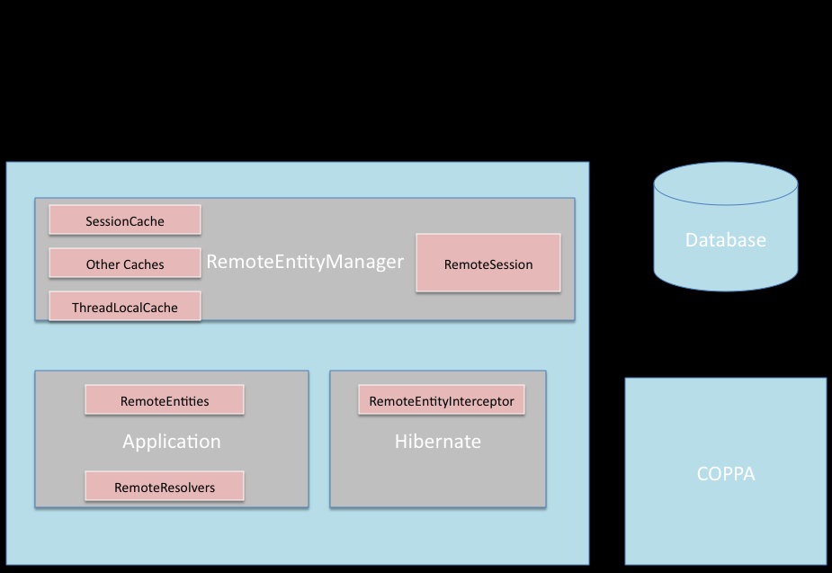
In order to fetch the latest values of an object at all times C3PR/CAAERS/CAAERS makes use of a callback feature in the relational persistence mechanism (Hibernate). The object passed by one data binding manager (Hibernate) is decorated by another DataManager (Remote Entity Resolver). Every entity that needs to be marked as remote will be extended to create two new classes; LocalEntity and RemoteEntity. Without sub-classing, its impossible to tell Hibernate what to save and what not to save. This approach also provides for the following advantages:
1) Annotating sub-classes provides a convenient (code-oriented) separation of responsibilities, allowing local data to be saved by Hibernate and remote data to be loaded by the custom interceptor/resolver,
2) Gives the flexibility to use “Single Table” or “Table per Concrete Class” mapping strategy. With a table per concrete class, the column constraints already in place can stay and no major database changes will be incurred.
The sub-classing strategy leverages the well-known Hibernate Inheritance Mapping strategy. None of the layers above the lowest data access layers need to know about the data source, which provides a clean architectural abstraction. The only code which knows about the data location will be the Resolvers, and it will behave differently depending on the annotated instance (Local or Remote).
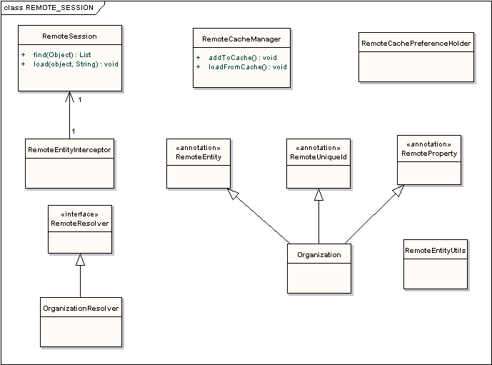

Development View
Protocol Abstraction
The modes of fetching the Protocol details can be split into two categories, Update and Amendment.
Update

The parts of the study that can change without requiring a formal amendment qualify as Updates. These attributes can be updated at any point without warning and thus are required to be fetched every time the corresponding object is displayed, irrespective of whether it’s a read or a write operation.

In the C3PR/CAAERS/CAAERS domain model, various attributes of the Study domain object fall under this category. These “updateable attributes” are the ones that will be annotated with @RemoteProperty. This will ensure that every time the Study object is loaded, fresh data will be fetched from COPPA and inserted into these attributes by the Hibernate Interceptor and displayed to the user.

One of the critical details in this approach is the transferring of data between collections while intercepting and populating the Hibernate Objects. There are two obvious approaches to this problem:

Approach 1: Custom Collection Wrapper with Lazy Loading

In this approach, a custom Collection is used that will have the Hibernate Collection, known as PersistentBag, as an attribute. The Hibernate bag in the Session is replaced with this custom collection by the interceptor. At this point the lists aren’t initialized. Whenever the collection is requested the custom wrapper will fetch all the remote attributes and update the PersistentBag. This is when the lists are initialized. This ensures that the collection associated with the Hibernate session is updated with the latest remote objects while still being able to use Hibernate mechanics to fetch the local data (through the aforementioned stored PersistentBag).

Approach 2: Eager Loading

In this approach all the associated lists of the object being loaded are fetched (eagerly initialized) in the interceptor itself. This is done so that the interceptor can fetch the remote data and update the PersistentBag with the latest data. This means that when the study is loaded the associated study sites, eligibility criteria etc are all updated and loaded eagerly. One of the inherent drawbacks of this approach is that it may not be efficient because data may (and will) get fetched that is not needed (or not immediately needed). However, the benefit is that the latest data will always be available to Hibernate’s lazy loading.

Every collection which is updated by COPPA needs to be a remote entity. This may or may not have a custom RemoteResolver. (This is a modification of the previous design which requires changes to the remote session). If they have a custom resolver they are expected to have a unique external Id and are called self-managed. The entities without a custom resolver (these will have the DefaultRemoteResolver) are called parent-managed.

The Interceptor fetches the latest remoteObject from the resolver and passes it to the object populator. The object populator updates the PersistentBag with the collection retrieved from the corresponding resolver. The strategy for updating depends on the entity (collection item) type. The entity can either be self-managed or parent managed.

- If the collection entity is self managed then it means it has its own resolver (and therefore a uniqueId). In this case the interceptor will do nothing as it will be updated by its resolver when being fetched/loaded.
- If the collection entity is parent managed then it means it is using the default Resolver and does not have a resolver of its own (may/may not have a uniqueId). In this case the interceptor will remove all the remote items from the collection and add all the remote items returned by the resolver.

The following table lists the attributes that fall under the Update category. Please note that this list is a work in progress and can be updated going forward.

Study Site Name
Study Site Target Accrual
Study Site IRB Approval Date
Study Site Start Date
Study Target Accrual
Study Personnel
Study Investigators

Amendment

The parts of the Study which cannot change unless there is a formal amendment qualify as amendment details. This basic nature of amendment details encourages the employment of a different strategy: the checking for Amendment Version before fetching fresh data.

In C3PR/CAAERS every Study has a list of StudyVersion objects, each of which correspond to an amendment version. They are sorted by the Amendment Date and the current Study Version is the one with the latest Amendment Date. C3PR/CAAERS does not update the current Study Version every time it is loaded, instead, at strategic points in the application (listed below) an Amendment version check is performed by making a COPPA service call, which tells C3PR/CAAERS if it has the latest version. If so, the values in the local database are used. If not, then the latest version is fetched from COPPA and a new Study Version with these values is created and inserted into the Study. This strategy ensures that the application only fetches amendment based data when they are updated and avoids unnecessary calls to COPPA services.

One of the critical decisions in this approach is determining when to check for the AmendmentVersion. The two workflows in C3PR/CAAERS that demand this check are:

- When the user clicks on a study in the study search results to enter Manage Study from where he can go into Amend or Edit flow.
- When the Create Registration Service picks up a study for accrual.

The following table lists the attributes that fall under this category. Please note that this list is a work in progress and can be updated going forward.

Phone Call Randomization Number
Stratification
Blinded Indicator
Multi Institution Indicator
Randomization Indicator
Stratification Indicator
Coordinating center
Coordinating center assigned Identifier
Funding Sponsor
PI
Short title
Phase
Type
Study Disease
Long Title

Some of the study associations which are more evolved are explained in further detail below.
Stratification (More details required)
Stratification Criterion and Answer Combinations which are captured by C3PR/CAAERS are not present in the COPPA model v2.2. However Stratum Groups will need to be fetched from COPPA services using the SubGroupsService.
Eligibility Criteria (More details required)
Eligibility Criteria is maintained by COPPA, however further details are required to determine how to construct the question and answers from the data that is available.
Coordinating Center (More details required)
This can be obtained from StudyParticipation with the functional Code LeadOrg.

Funding Sponsor (More details required)
This can be obtained from StudyParticipation with the appropriate functional Code.

Study Status (More details required)
Points to be noted while deriving the study status are:

For Amendments: Trial must have a Processing Status = Abstracted
For Updates: Trial must have a Processing Status = Abstracted (assuming that eventual anticipated timeline between Accepted and Abstracted state is a few days)

Glossary
Term | Meaning

